THM 415 Finance
Formulae Sheet Paper
Midterm Exam
Chapter 3
Profits = Revenues – Expenses
Earnings Per Share (EPS) = Net Income / Number of Outstanding Common Shares
Dividends Per Share (DPS) = Total Dividends Paid / Number of Outstanding Common Shares
Gross Profit Margin = Gross Profits / Net Sales
Operating Profit Margin = Net Operating Income / Net Sales
Net Profit Margin = Net Profits / Net Sales
Total Assets = Total Liabilities + Total Shareholders’ Equity
Net Working Capital = Current Assets – Current Liabilities
Change in Cash Flow (Year_{t}) = Ending cash Balance (Year_{t}) – Ending Cash Bance (Year_{t-1})
Quality of Earnings = Cash Flow From Operations / Net Income
Capital Acquisitions Ratio = Cash Flow From Operations / Cash Paid For Capital Expenditures

Chapter 5
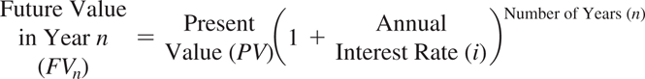
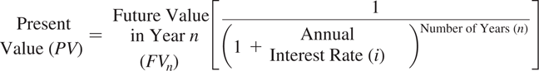
Approximation Formula: Nper = 72/interest rate
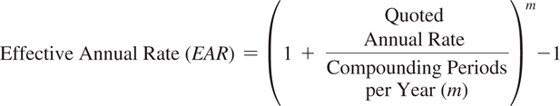
EAR = (e ^{quoted rate} ) – 1 (Continuous Compounding)

Chapter 6
Ordinary Annuity
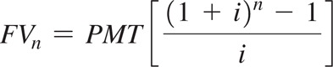
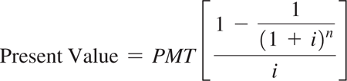
Annuity Due
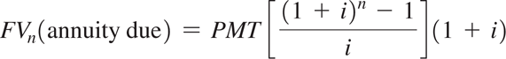
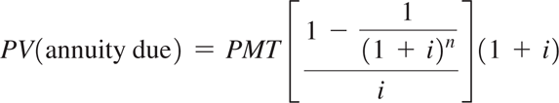
Perpetuity
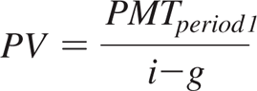

Chapter 7
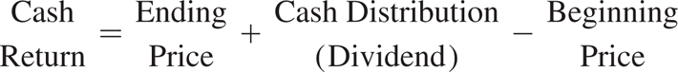
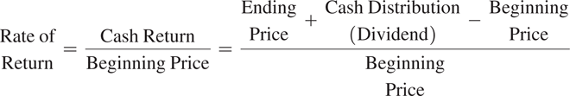
Variance
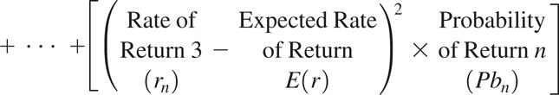

Chapter 8
Portfolio Standard Deviation (with 2 assets)

